FACULTY OF APPLIED FUNDAMENTAL SCIENCES

***Scientia et Lux***

B.P. 155

Ruhengeri

Rwanda

**T**

: +250

30 30

788 90

: +250

30

32

788 90

**W**

:

[w](http://www.ines.rw/)

[www.ines.ac.r](http://www.ines.rw/)

**E**

:

inesruhengeri@yahoo.fr

**INSTITUT D’ENSEIGNEMENT SUPÉRIEUR**

**DE RUHENGERI**

***Accrédité par***

***Arrêté Ministériel N° 005/2010/Mineduc***

***du***

***Ju***

***16***

***in***

***2010***

***Scientia et Lux***



**GROUP 4 ASSIGNMENT**

**Musanze,**

**Novemberer**

**2024**

DEPARTMENT OF COMPUTER SCIENCE

OPTION OF SOFTWARE ENGINEERING

ARTIFICIAL INTELIGENCE

­­­

Year III SWE Group B

Members

IRUTABYOSE Yoramu 23/22764

MASONGA SHEMA Prince 23/20861

ISHIMWE Kevin 23/22823

IZABAYO HARANIRA Jean Luc Severin 23/22493

ISHIMWE HABYARIMANA Regis 23/19890

ISHIMWE HITAYEZU Herve 23/22202

**Day 3 Report:**

**Group #4**

**Final Development, Testing & Deployment**

**1. Final Development**

* **Full Rule Implementation:**
  + Added additional rules to enhance the accuracy of crop recommendations.
  + Optimized rule-based logic for better performance.
  + Integrated error handling to prevent invalid inputs.

**2. System Testing & Documentation**

* **Testing Scenarios:**
  + Verified correct crop recommendations for different climate inputs.
  + Tested system stability under various user interactions.
  + Ensured smooth user experience on Binder deployment.

**Screenshots:**

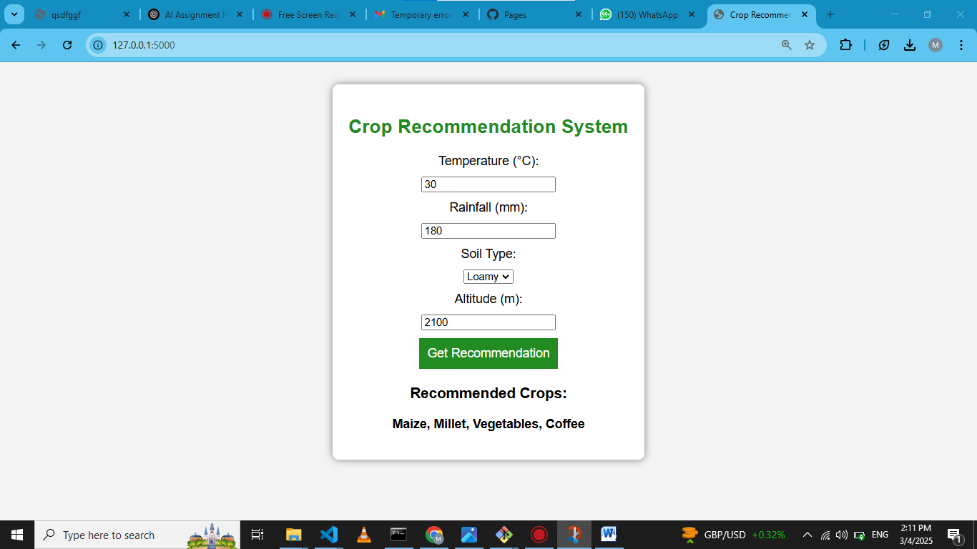

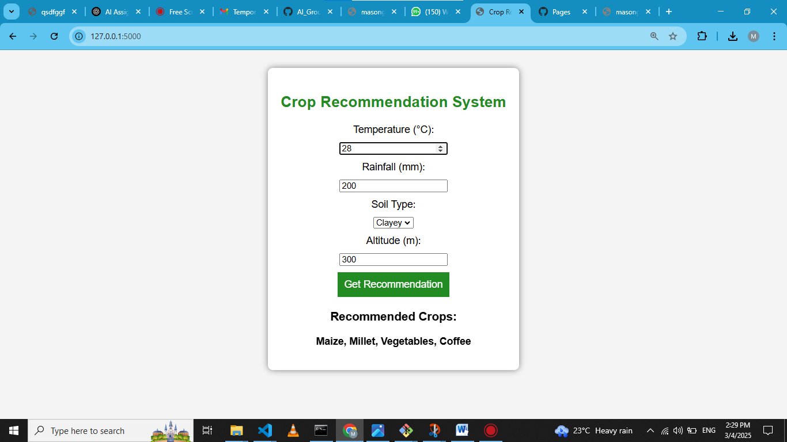

**3. User Manual**

* **How to Use the System:**
  + Open the web application using the GitHub Pages link.
  + Enter temperature, rainfall, soil type, and altitude.
  + Click ‘Get Recommendation’ to receive suggested crops.
  + Review the results displayed on the screen.

**Screenshots(result):** 

**4. Deliverables**

* **GitHub Pages Link:** *(*[**https://masonga-dev.github.io/AI_Group4_ExpertSystem_Assignment2/**](https://masonga-dev.github.io/AI_Group4_ExpertSystem_Assignment2/)*)*
* **PDF Report:** *(This document, including all sections with screenshots added)*

**5. Conclusion**

* The expert system for agricultural crop recommendation is fully developed.
* The system has been successfully tested and deployed.

**GitHub & Deployment Links:**

* **GitHub Repository:** [Masonga-Dev/AI_Group4_ExpertSystem_Assignment2](https://github.com/Masonga-Dev/AI_Group4_ExpertSystem_Assignment2)
* **Binder Web App:** [Launch App](https://mybinder.org/v2/gh/Masonga-Dev/AI_Group4_ExpertSystem_Assignment2/main?urlpath=proxy/5000/)
* **GitHub Pages:** [**https://masonga-dev.github.io/AI_Group4_ExpertSystem_Assignment2/**](https://masonga-dev.github.io/AI_Group4_ExpertSystem_Assignment2/)